**Twitter Stream Analysis**

**Screenshots**

**Initial page:**

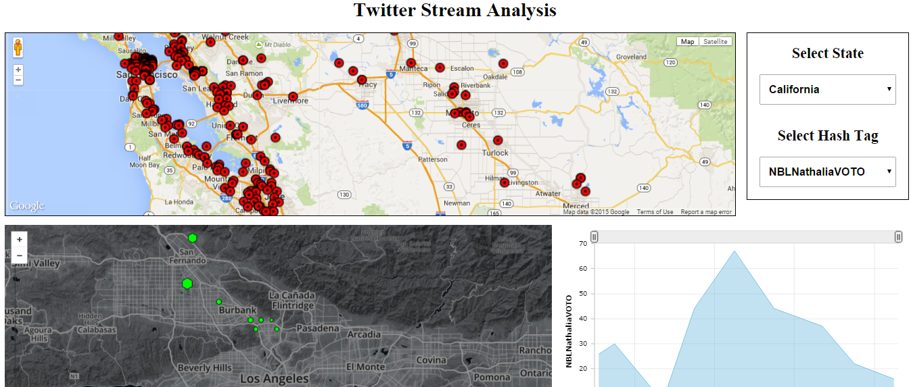

**Google Chart showing each tweet details( User 🡪 Tweet ):**

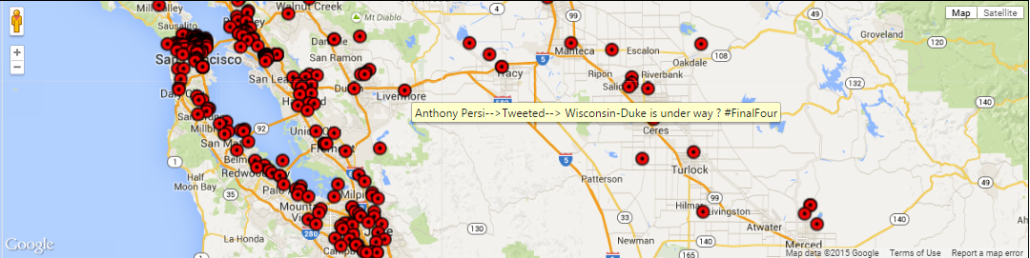

**Top 10 hash tags loading with respect to the state:**

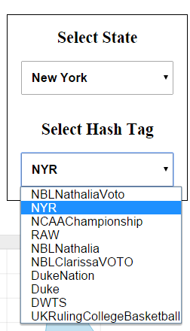

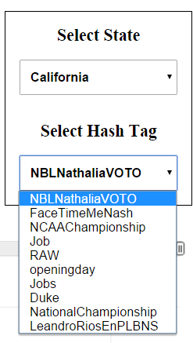

**Hexbins showing frequency of selected hashtags of the selected state:**

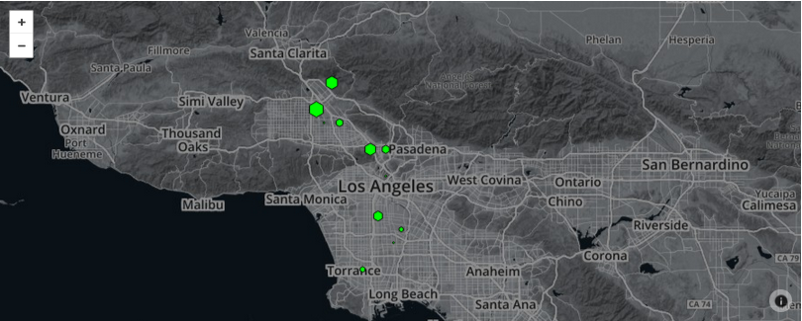

**Area Chart showing exact count of the selected hashtag at 10 minute**

**interval time in the selected state:**

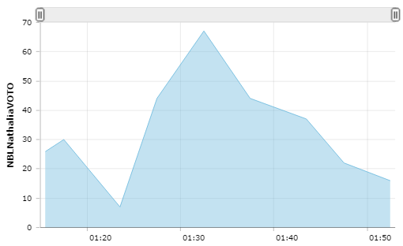

**Page updates when state changes:**

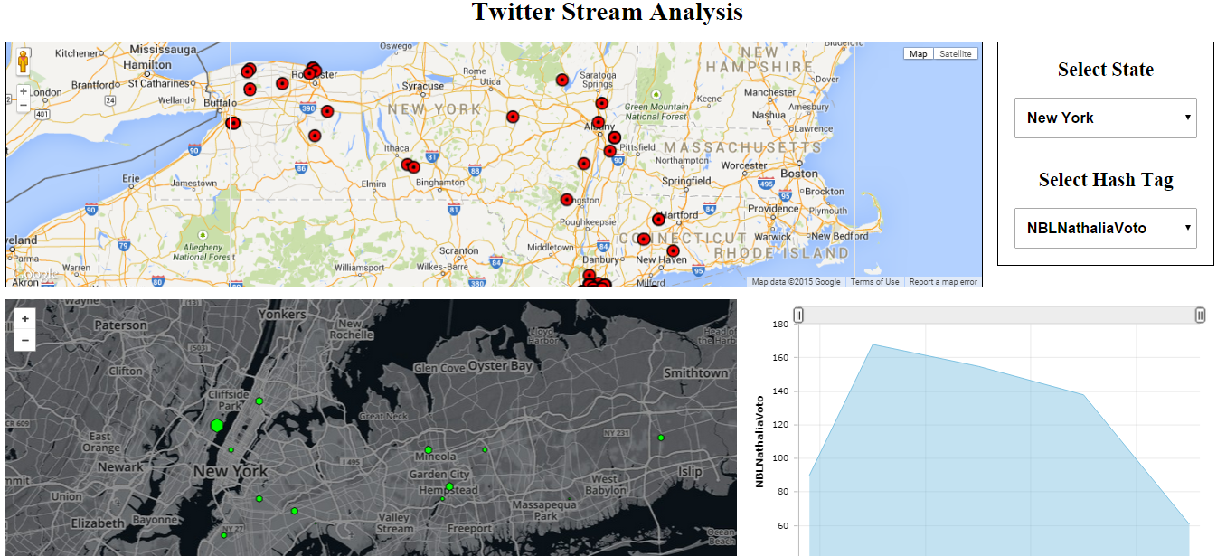

**Page updates when hash tag changes:**

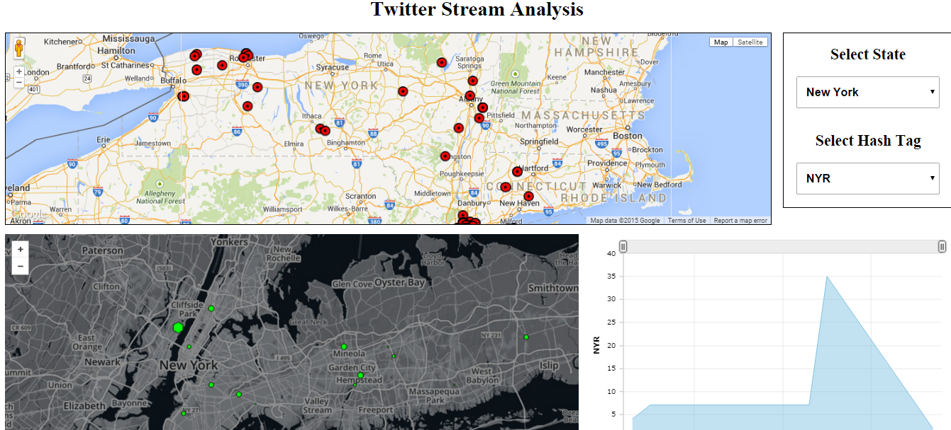

**Team Members:**

1. Arunkumar Bagavathi (800888454)

1. Deepak Rohan Sekar (800887228)

1. Ganesh Ramamoorthy (800887691)

1. Jinfeng Du (800815618)